 **Lab Terminal**

**Submitted By :Nida Eman**

**Reg No: fa21-bcs-002**

**Submitted to : Sir Bilal Haider**

**Course: Compiler Construction**

**Date: 3/1/2025**

**Qs2 :**

**Input and Output of MIniCompiler ?**

Input is the source code with in the file Program.cs .form which it will ask the user to enter the code and from this the form will generate the input.

**Input:** The input is a source code written in a basic programming language (e.g., int a = 10;).

- **Output:** The output consists of:

- **Tokenized Output:** A list of tokens extracted from the source code.

- **Parsed Output:** A success/failure message indicating whether the syntax is correct.

- **Semantic Analysis Output:** Messages indicating any logical errors.

- **Optimized Code:** The optimized version of the source code.

- **Symbol Table:** A list of variables, functions, and other symbols used in the code

**Input :**

int a = 10;

int b = 20;

if (a > b)

{

int temp = a;

a = b;

b = temp;

}

**Lexer.cs**

**The first step of starting the mini compiler it will oass the code through the lexical analyzer.**

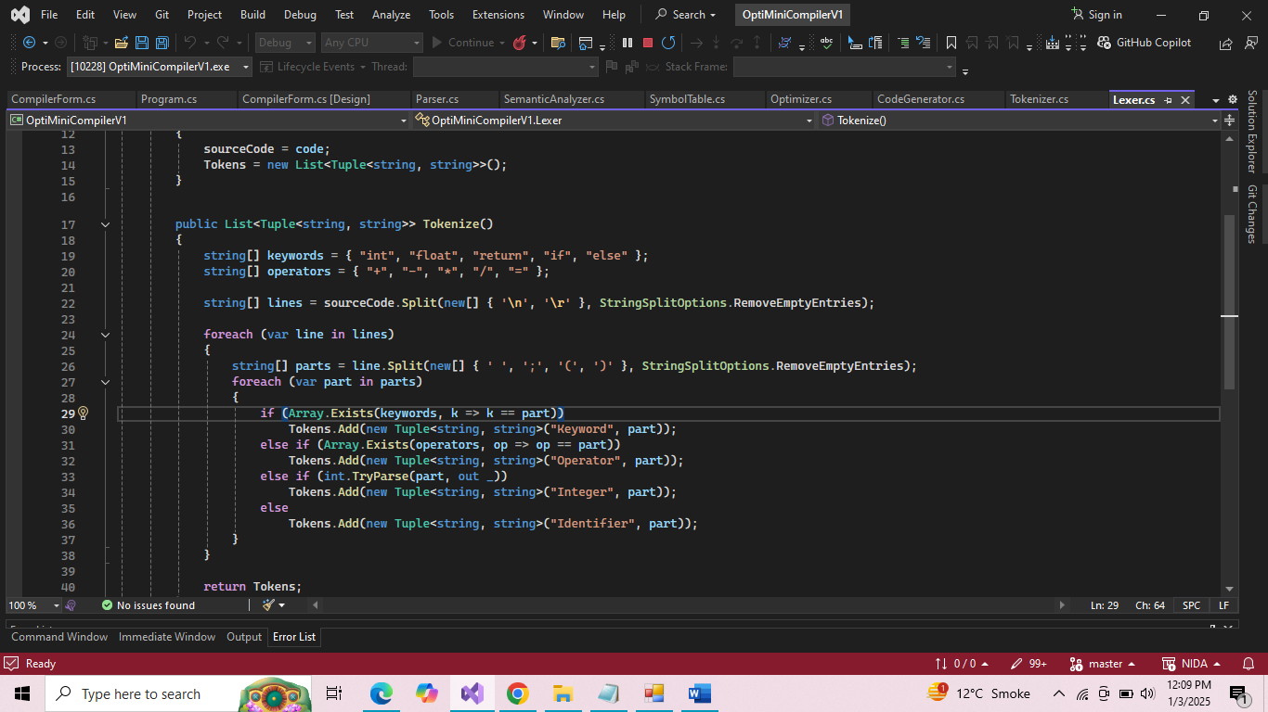

**Tokenizer.cs:**

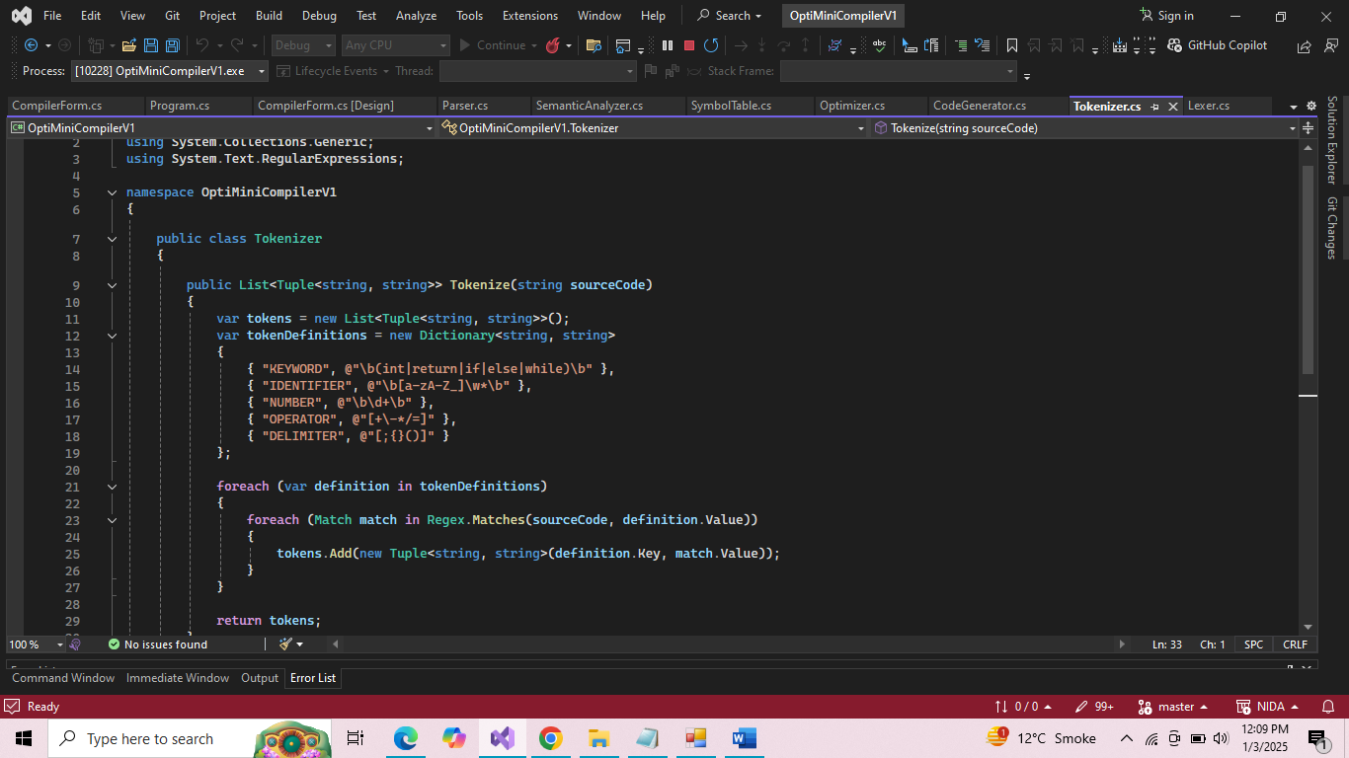**Optimizer.cs**

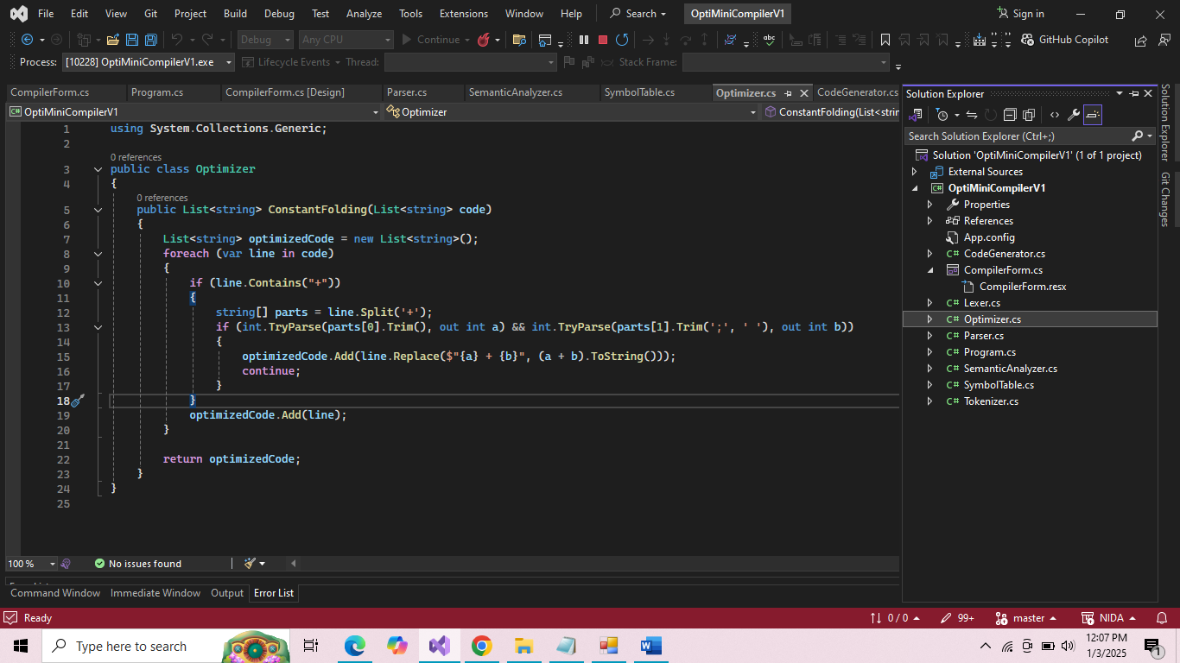



**Symbol Table.cs**

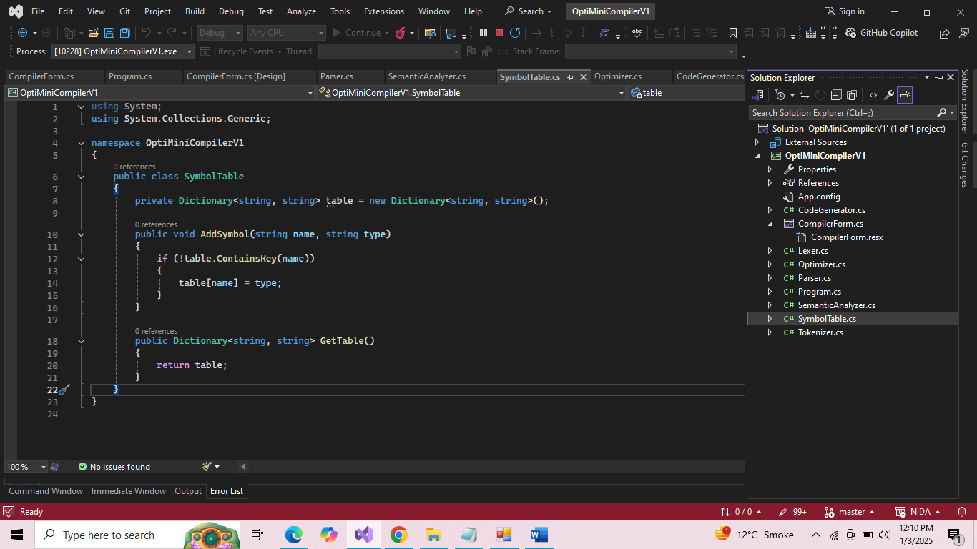

**SematicAnalyzer.cs**

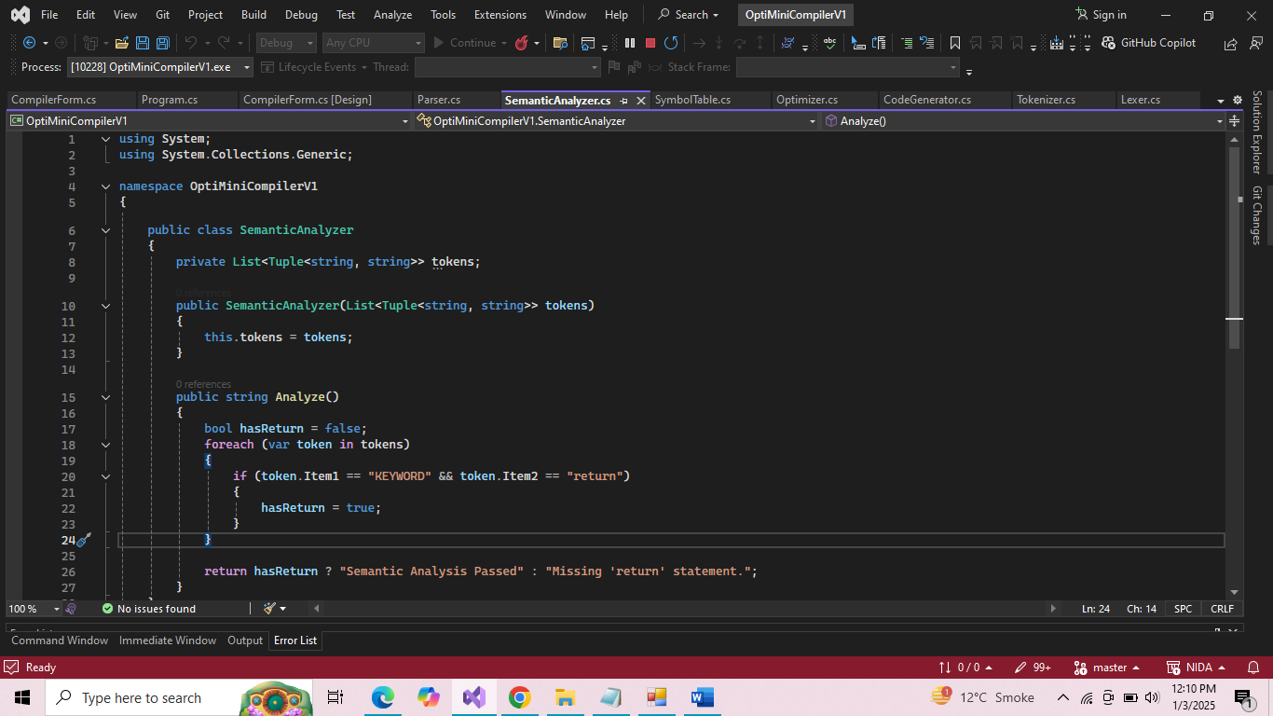

**Parser.cs**

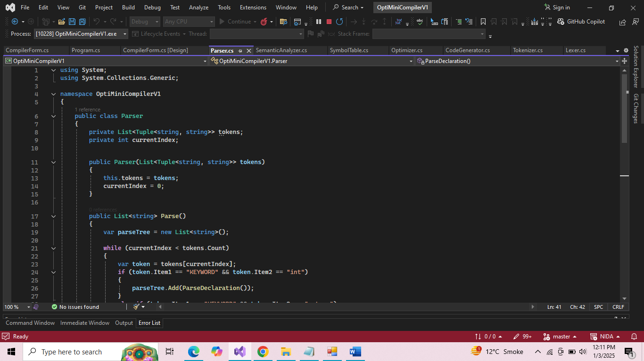

**Ouput:**

